Southeastern European Regional Programming Contest
Bucharest, Romania
October 23, 1999

Problem G
Title Lines

Input File: G.DAT
Program Source File: G.PAS or G.C or G.CPP

The chapters of a book are stored in a text file as non-empty and possibly long sequences of lines, a sequence for each chapter. Each sequence contains ordinary lines and title lines.

- Ordinary lines correspond to the text lines of the chapter. An ordinary line is different from all the other lines in the same sequence.

- Title lines correspond to the title of the chapter. All the title lines from the same sequence are identical. There are at least 2 title lines in a sequence and, moreover, the number of title lines count for at least 10% out of the total number of lines in the sequence. Title lines can occur anywhere in the sequence.

All lines from the same sequence have the same length. The lines from different sequences can have different lengths. Each sequence is preceded by a count line that specifies the number of lines in the sequence (at most 106 lines). The characters CR (carriage return, decimal ASCII code 13) and LF (line feed, decimal ASCII code 10) terminate each line in the file. The length L of a line is 3 ≤ L ≤ 82 (including CR, LF). The count, ordinary and title lines are the only lines in the file. The data are correct.

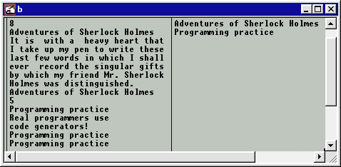
Write a program that processes a text file as that described above and, for each sequence of lines from the file, prints on the standard output the title line of the sequence. Each result is printed on a separate line, as illustrated in figure 1.
input output

Figure 1. An example of program input and output

The input file from figure 1 contains two sequences of lines. The first sequence has 8 lines of 33 characters each (including CR, LF). There are two title lines Adventures of Sherlock Holmes making up 25% out of the lines in the sequence. The second sequence has 5 lines of 22 characters each (including CR, LF). There are 3 title lines Programming practice making up 60% out of the lines in the sequence.

Please, before going on with the problem, imagine that you are hunting in dense forest. An amazingly good option is to keep shooting at random.

